YEAR 10 SCIENCE (ADJUSTED)
PHYSICAL SCIENCES
REVISION - SEM. 2 EXAM 2019

1. A F1 car accelerates from rest at the Singapore Grand Prix and reaches the first corner
350 m away in 6.0 s with a final speed of 73 m/s. Calculate the acceleration of the vehicle.
(Use )

2. A person is taking photos from a balloon hovering 300 m above a paddock near Northam. She accidentally drops her phone and watches it smash into the ground 7.8 s later. Assume the initial velocity of the speed is zero and the acceleration due to gravity is 9.8 m/s². How fast was the phone moving when it hit the ground? (Use v = u + at)

3. A dragster moving at 92 m/s at the end of a race pops its parachute and uses its brakes to come to a stop in 6.0 s.

(a) What is its deceleration? (Use )

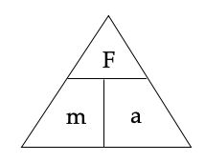
(b) If the dragster has a mass of 930 kg, what force was applied by the parachute and the brakes?

4. Complete these statements about Newton’s three laws of motion.

(a) An object remains at rest, or will not change its speed or direction, unless ...

(b) When an unbalanced force acts on an object, the mass of an object affects ...

(c) For every action, there is ...



5. Complete the following table.

Force | Mass | Acceleration
400 N |  | 3 m/s²
 | 6.0 kg | 7 m/s²
4.8 N | 0.9 kg

6. (a) What is inertia?

(b) Which has the most inertia - a truck or a car?

(c) Which is the easier to stop quickly with its brakes? Explain why.

7. (a) What happens to you when you are standing on the train and it suddenly takes off from the station?

(b) Why does this happen?


8. Use Newton’s Second Law to calculate answers for the following.

(a) A 1700 kg car accelerates at 4.9 m/s². What size force is needed to cause this acceleration?

(b) A force of 250 N causes an object to accelerate at 3.0 m/s². What is the object’s mass?

(c) A force of 450 N acts on a mass of 150 kg. What is the acceleration?

9. (a) Explain the difference between mass and weight.

(b) Are you lighter or heavier on the Moon? Explain why.

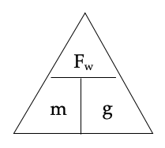
(c) The acceleration due to gravity on Jupiter is 22.5 m/s². Calculate the weight of a 450 kg object on Jupiter.

10. Consider the forces acting on a body of mass 20 kg resting on a frictionless surface.

(a) Calculate the nett force acting on the body.

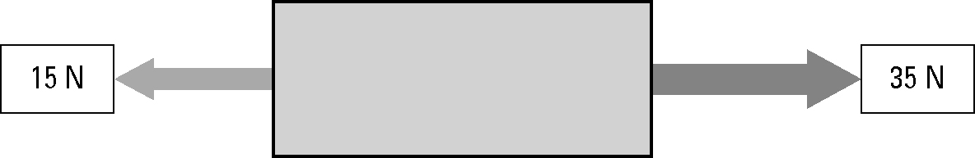



(b) Calculate the acceleration of the body.

